**LONG TRAN**

CURRICULUM VITAE

Updated: Oct 05, 2020

PERSONAL INFORMATION

|  |  |
| --- | --- |
| **TRAN QUANG LONG**   * **Date of Birth:** March 02nd 1984 * **Marital Status:** Married * **Phone:** +84 941819833 * **Email**: tqlong.net@gmail.com * **Skype**: long.tran.84 | *I’m a hardworking, dedicated person.*  *My interest is programming* |

**TECHNICAL COMPETENCIES**

|  |  |
| --- | --- |
| **Blockchain(Hyperledger)**   * Hyperledger Fabric SDK * Fabric-chaincode-java * Fabric-gateway-java * Iroha-java   **AI(Artificial Intelligence)**   * TensorFlow * Deeplearning4j   **Apache**   * Apache Kafka * Apache Storm * Apache Mahout as Recommendation Engine * Apache Cassandra * Apache Hadoop * Apache Spark™   **Android Development**   * Android Development, JNI * Android Wear * Android TV * Android Auto * Android ZigBee Interface * Android Health & Fitness * GUI Layout Development   **BlackBerry Development**   * Java Development * Native SDK * GUI Layout Development   **IBM Development**   * WebSphere MQ V7.0 * WebSphere Commerce V6.0 * WebSphere Application Server Network Deployment V7.0   **Java EE Servers**   * GlassFish Server * JBoss Enterprise Application Platform * Jetty * Jrun * WebLogic Server * IBM WebSphere Application Server * Play Framework   **Oracle Technologies**   * Oracle Portal * [WebLogic Server](http://www.oracle.com/us/products/middleware/application-server/index.html)   **Cloud technologies**   * Fluent: AWS: EC2, S3, DynamoDB, CloudFormation, [ElastiCache](https://console.aws.amazon.com/elasticache/home?region=us-east-1), VPC, CloudFront , Route 53, Athena EMR, Elasticsearch Service, Kinesis, SQS, SNS, SES, Rekognition, Machine Learning. * Basic: GoogleAppEngine   **Other Technologies**   * Jasperreports, iReport-3.0.0 * Codenameone(Easily create amazing, fast, native mobile apps using Java™ for all platforms! <http://code.google.com/p/codenameone/>) * Scala Technology (<http://www.scala-lang.org/>) * Performance tuning techniques and tools (JMeter, Gatling) * Hadoop & Big Data * Cluster, Web Load Balancing | **J2ME Development**   * Java Development * GUI Layout Development   **J2EE Development**   * Java Development * Java Server Faces(jsf), JSP, Struts 2, Spring, EJB 3, ServiceMix, JMS, ActiveMQ, Hibernate, Velocity * dotCMS is an open source Java Web Content Management System (CMS) * Liferay Portal, Jetspeed Portal * The Scala Programming Language * Vaadin : Vaadin is a Java framework for building modern web applications that look great, perform well and make you and your users happy   **HTML/CSS Development**   * JUnit * Cactus   **Testing Tools**   * JUnitPerf * Mockrunner * JTestCase * jMock * TestNG * JTR Java Test Runner * SoapUI * Selenium * EvoSuite * Citrus * Quick Test Pro * Quality Center * Load Runner * Test Director * Win Runner * Rational Administrator * Rational Test Manager * Rational Robot   **Defect Tracking Tools**   * Clear Quest * Tracker * Bugzilla   **Requirements Management Tools**   * DOORS * Rational Requisite Pro   **Development Tools**   * SVN, git * Eclipse IDE * Android Studio * Netbeans * WebSphere Studio * Oracle Jdeveloper * IntelliJ IDEA * Ant, Maven, Gradle * Jenkins, Hudson   **Project Management**   * Microsoft Project * Microsoft Visio   **Operation Systems**   * Microsoft Windows * Linux, AIX, Solaris 10 |

PROFESSIONAL EXPERIENCE

**VNEXTソフトウェア (09.2017 ~ now)**

**J2EE, Android, IoT, Nodejs, Vue.js, AI, BlockChain**

**Software Architecture**

Responsibilities include:

* Development with J2EE, Android, IoT, AI, Blockchain Hyperledger

**SETA International LLC (02.2012 ~ 0.8.2017)**

**Big Data/Hadoop**

Summary:

* Over 3+ years of experience in Hadoop, HDFS, HBASE, Hive, pig and OBIEE with hands-on project experience in various Vertical Applications which includes Enterprise, Telecom, Financial Services, and eSales.
* Extensive Experience on Linux, Shell Scripting and SQL.
* Good Experience SQL performance Tuning.
* Expertise in HDFS Architecture and Cluster concepts.
* Extremely motivated with good inter-personal Skills; have ability to work in strict deadlines.
* Expertise in Hadoop Security and Hive Security.
* Expertise in Hive Query Language and debugging hive issues.
* Expertise in sqoop and Flume.
* Extended Table columns for custom fields as per business requirements.
* Expertise in OBIEE and DWH Concepts.
* Providing hardware architectural guidance, planning and estimating cluster capacity, and creating roadmaps for Hadoop cluster deployment
* Provisioning, installing, configuring, monitoring, and maintaining HDFS, Yarn, HBase, Flume, Sqoop, Oozie, Pig, Hive.
* Involved in Hadoop Cluster environment administration that includes adding and removing cluster nodes, cluster capacity planning, performance tuning, cluster Monitoring, Troubleshooting.
* Adding new nodes to an existing cluster, recovering from a Name Node failure.
* Decommissioning and commissioning the Node on running cluster.
* Installation of various Hadoop Ecosystems and Hadoop Daemons.
* Recovering from node failures and troubleshooting common Hadoop cluster issues.
* Scripting Hadoop package installation and configuration to support fully-automated deployments.
* Supporting Hadoop developers and assisting in optimization of map reduce jobs, Pig Latin scripts, Hive Scripts, and HBase ingest required.

**South East Asia Information Technology Joint Stock Company (SEATECH)** **(01.2009 ~01.2012)**

**Senior Software Developer**

Responsibilities include:

* Development with J2ee,J2me(Banking, Securities)

**IFISOLUTION (2006 - 2008) (**www.**ifisolution**.com)

**Software Developer**

Responsibilities include:

* Web development with J2ee

MAJOR PROJECTS VNEXTソフトウェア

**Project** **UcarPac Blockchain in automotive :**

* **Technology:**  Java, Blockchain Hyperledger
* **Scope:** Blockchain in car manufacturing Supply chain management. Car parts could be lost in delivery, stolen, replaced, damaged, etc. Blockchain would allow the manufacturer to have a complete follow-up of these pieces. In the case of a recall, blockchain would also facilitate the procedures: since it carries the information on the origin of the piece, we could control if any modifications have been made to it or if a manufacturing defect occurred. Manufacturing processes. There are numerous opportunities to take advantage of blockchain technology throughout the automotive manufacturing process. We can use blockchain to store data from bills of lading for vehicle components and quality-inspection records created during the manufacturing process to WIP information for each vehicle assembly from start to finish. Finances. All processes that require manual data insertion, include transactions or transaction costs, as well as revisions, among other things, could be streamlined. The Blockchain would accelerate these processes and keep them updated throughout the lifecycle of a car. Vehicle safety and data security. The more connected a vehicle is, the more susceptible it becomes to potentially deadly cyber attacks. Thanks to blockchain’s strong cryptographic roots that cannot be reverse-engineered, it is the perfect place to store data since it cannot be changed. Telematics. In the connected car space, telematics includes software-based navigation, vehicle-to-vehicle (V2V) communications, and a host of other services that can affect vehicle safety and passenger security. We can use blockchain to keep safe the data sent and received by telematics systems. The heightened level of encryption prevents hackers from viewing or using this data. Smart insurance. Blockchain technology enables the unmanipulable and transparent logging of the vehicles’ sensor data in a decentralized network. This unimpeachable documentation of a blockchain “black box” could help to resolve the circumstances of an accident, especially when it comes to autonomous vehicles. Blockchain could also enable insurances to be taken into other vehicles like a user profile, for example in carsharing.
* **Environment:** AWS.
* **Responsibilities** :

1. Research and development

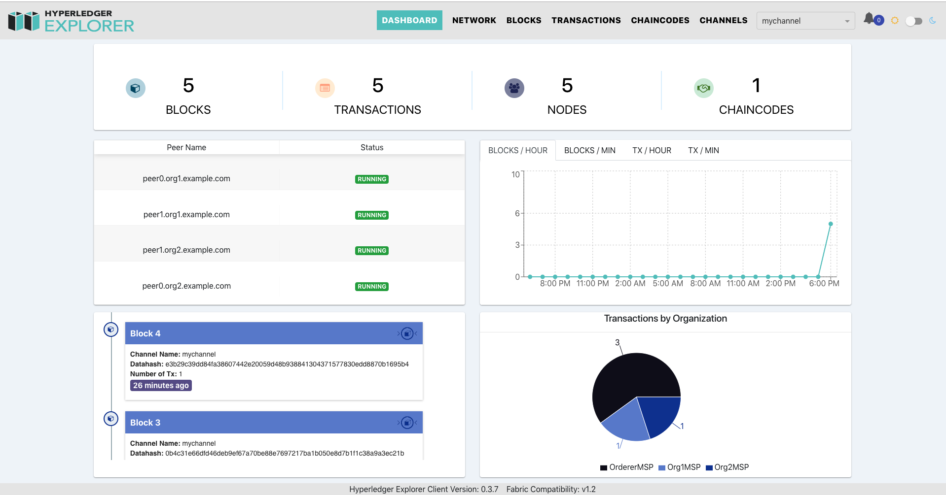

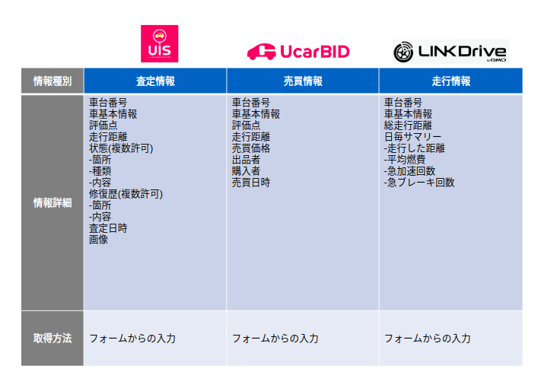

**Project** **WIFI** **Router (Development & Technical)(http://www.prolink2u.com/):**

* **Technology:**  Android/JNI
* **Scope:** Portable 4G LTE WiFi Hotspot Data speed up to 150Mbps Rechargeable battery up to 9 hours Share internet connection with up to 10 users Compact and Light-Weight.
* **Features:** PROLiNK® PRT7010L Portable 4G LTE Wi-Fi Hotspot is a device which is able to provide high speed data transfer of up to 150Mbps and Wi-Fi sharing of up to 10 users or devices. The powerful Li-Ion battery allows users to stay connected for up to 9 hours on a single charge without worry of needing a power point. The device also comes with 4 LED lights on its front panel which allows users to get a clear indication of the current battery status, Wi-Fi strength, 4G signal strength and SMS notification at a glance. The PROLiNK PRT7010L is a simple and high speed portable Wi-Fi Hotspot that is suitable for most users.
* **Environment:** Android OS.
* **Responsibilities** :
  1. Research and development

**Project** **Car Parking App : Pay to Park by Phone:**

* **Technology:**  IOS, Android/JNI
* **Scope:** Our new Car Parking App With a new look and feel, the app helps you pay more quickly and easily by highlighting only your closest Car Parking App parking zones. To quickly find a place to park in other locations, either on street or in car parks, just search via the map. With payment by credit card or debit card, Car Parking App makes it easy to use your phone and pay for your parking.
* **Environment:** IOS, Android OS.
* **Responsibilities** :
  1. Research and development

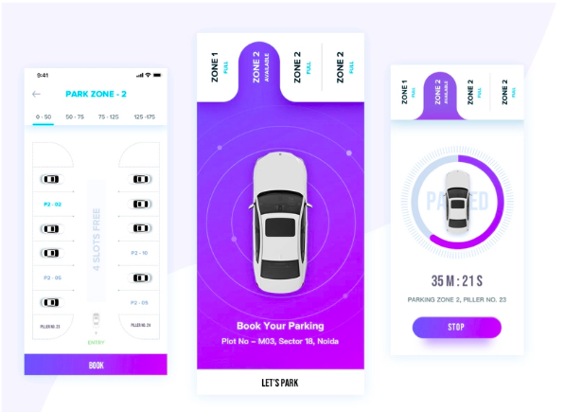

**Project** **Parking Finder Apps:**

* **Technology:**  IOS, Android/JNI
* **Scope:** Setting up of the operational zone The operational zones where vehicles can be parked can be easily provided with this app. The location of the parking area in a certain zone becomes essential As it can provide information with minimal services. Heat map view The real-time locations can be predicted with heat view map and it shows the busiest location in a day. Because of which, convenient decisions can be taken by the users and they can prosper with their decisions. In-app communication When you are doing business, communication is the key element in the success of it. There are many ways of communication like emails, SMS’s, or about any kind of updated features and services. This is important for the drivers as they can communicate with their users to reach the desired location.
* **Environment:** IOS, Android OS.
* **Responsibilities** :
  1. Research and development

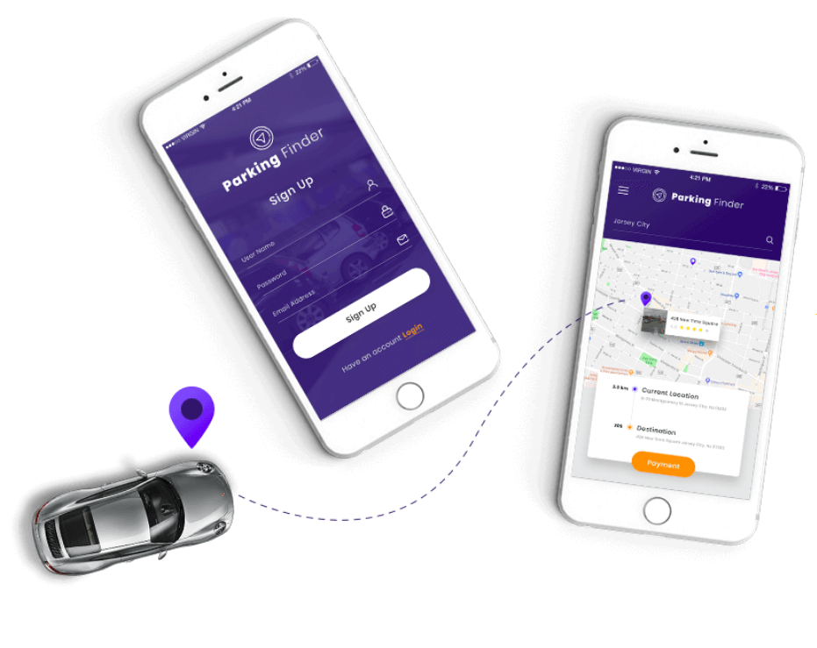

**Project** **helloworld.com.au (Development & Technical):**

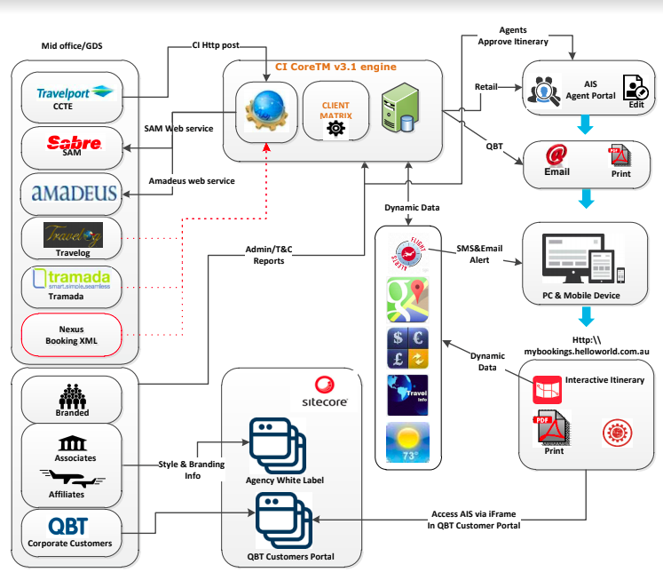

* **Technology:**  J2EE, J2SE, UNIX, MySQL, Nodejs, Vue.js
* **Scope:** booking system.
* **Features:** 
  1. Send Automatic Appointment Reminders
  2. SMS text reminders can reduce no-shows by over 80%, and also greatly reduce the incidence of last minute cancellations.
  3. You'll quickly notice the decrease in costly no-shows and tardy clients.
  4. Manage Client Information
  5. bookitlive allows you to collect whatever information you want during the booking process: Name, Email, Address, Phone Number or any other questions you want to ask.
  6. That information is stored in an easy to use client database and allows you to directly send them an email or SMS and view their booking history.
  7. Have an existing client database? You can import all of your existing clients directly into bookitlive. You can also export the client details to a Excel spreadsheet for mailchimp marketing campaigns.
  8. Accept Booking Payments
  9. bookitlive allows you to take payments online at the time of booking. We support all currencies and are integrated with payment providers PayPal and SecurePay.
  10. Manage Daily Deals
  11. bookitlive has daily deal features that allow you to take online redemptions and increase the profitability of running daily deals. We support deal companies from around the world.
  12. With bookitlive you can reduce your overheads, improve client satisfaction and capture your clients information to help convert from new clients into repeat clients.
* **Environment:** CentOS.
* **Responsibilities** :

1. Development

MAJOR PROJECTS SETA International LLC

**Project** **Health Care Services (Development & Technical):**

* **Technology:**  J2EE, Vue.js
* **Scope:** Accident data collected from Great Bristain’s sourced into HDFS. Data cleansing and business transformations are implemented in Hadoop ecosystem. The data is provisioned to downstream systems for reporting and dash boarding purposes.
* **Features:** Health Care Services
* **Environment:** CentOS.
* **Responsibilities** :

1. Installed and configured multi-nodes fully distributed Hadoop cluster
2. Involved in installing Hadoop Ecosystem components.
3. Responsible to manage data coming from different sources
4. Involved in Hadoop Cluster environment administration that includes adding and removing cluster nodes, cluster capacity planning, performance tuning, cluster Monitoring, Troubleshooting.
5. Supported Map Reduce Programs those are running on the cluster
6. Involved in HDFS maintenance and administering it through Hadoop-Java API.
7. Configured Fair Scheduler to provide service-level agreements for multiple users of a cluster.
8. Maintaining and monitoring clusters. Loaded data into the cluster from dynamically generated files using Flume and from relational database management systems using Sqoop.
9. Managing nodes on Hadoop cluster connectivity and security.
10. Involved in writing Java API's for interacting with the HBase.
11. Involved in writing Flume and Hive scripts to extract, transform and load the data into Database.
12. Used HBase as the data storage

**Project** **BFF (Development & Technical):**

* **Technology:**  J2EE, J2SE, UNIX, MySQL
* **Scope:** The purpose of the project is to perform the analysis on the Effectiveness and validity of controls and to store terabytes of log information generated by the source providers as part of the analysis and extract meaningful information out of it. The solution is based on the open source Big Data software Hadoop. The data will be stored in Hadoop file system and processed using Map Reduce jobs, which intern includes getting the raw data, process the data to obtain controls and redesign/change history information, extract various reports out of the controls history and Export the information for further processing.
* **Environment:** UNIX.
* **Responsibilities:**

1. Worked on setting up pig, Hive and HBase on multiple nodes and developed using Pig, Hive and HBase, Map Reduce.
2. Developed Map Reduce application using Hadoop, Map Reduce programming and HBase.
3. Involved in developing the Pig scripts
4. Spring MVC
5. Involved in developing Reports and charts using JChart library.
6. Developed the Sqoop scripts in order to make the interaction between Pig and MySQL Database.

**Project** **Sentiment Analysis on customer evolution in banking domain (Development & Technical):**

* **Technology:**  J2EE, Apache Pig, LINUX, MySQL
* **Scope:** The purpose of the project is to store information generated by the bank’s historical data,extract meaning information out of it and based on the information predict the customer’s category. The solution is based on the open source Big Data s/w Hadoop .The data will be stored in Hadoop file system and processed using Map/Reduce jobs for product and pricing information.
* **Features:**  Analysis
* **Environment:** LINUX.
* **Responsibilities:**

1. Involved in developing the Pig scripts
2. Developed the Sqoop scripts in order to make the interaction between Pig and MySQL Database.
3. Completely involved in the requirement analysis phase
4. Spring MVC.
5. Did EDA on the data set and carefully removed the irrelevant data items

**Project** **Preparing a web interface for hbase (Development & Technical):**

* **Technology:**  Ubuntu,Hadoop, Apache Pig, Hive, SQOOP, MapReduce, LINUX, MySQL
* **Scope:**
* **Features:**
* **Environment:** LINUX.
* **Responsibilities:**

1. Fetched data from hdfs using pig,hive,MapReduce into HBase.
2. Fetched data from existing MySQL database to HBase using Sqoop and MapReduce.
3. Provided a UI to enter user’s query which would be parsed and executed internally and result would be displayed on the web interface.

**Project** **Slyde (Development & Technical):**

* **Technology:**  Core Java, Oracle, Apache Hadoop, Pig, Hive, Map-reduce, Sqoop, JAVA/J2EE, LINUX
* **Scope:**
* **Features:**
* Reel in deals from local shops and restaurants— and enjoy surprise perks when you are nearby and personal service when you pop-in
* Reap the rewards of loyalty automatically when you purchase—without punch cards or having to search for a store’s loyalty app.
* Truly “touch-less” pay. Link your credit card and you’ll never have to open your wallet or touch your phone again.
* **Environment:** LINUX.
* **Responsibilities:**

1. Handled importing of data from various data sources, performed transformations using Hive, PIG, and loaded data into HDFS.
2. Experience in Importing and exporting data into HDFS and Hive using Sqoop.
3. Load and transform large sets of structured, semi structured and unstructured data.
4. Responsible for managing data coming from different sources.
5. Gained good experience with NOSQL database.
6. Involved in creating Hive tables, loading with data and writing hive queries, which will run internally in map, reduce way.
7. Involved in creating tables, partitioning, bucketing of table.
8. Good understanding and related experience with Hadoop stack-internals, Hive, Pig and Map/Reduce.

**Project** **BabbleSphere (Development & Technical):**

<https://play.google.com/store/apps/details?id=com.babblesphere.recorde>

* **Technology:** Android , JNI
* **Scope:** BabbleSphere lets you record 60 second audio clips and post them publicly on BabbleSphere.com or share them with your friends on Facebook. You'll be able to tell your friends how you feel with not just words, but with your voice!
* **Features:** record audio
* **Responsibilites:** JNI LIB LAME MP3 Encoder

**Project** **Augmented Reality Tech For Beauty Brands (Development & Technical):**

<https://play.google.com/store/apps/details?id=com.modiface.nailsalon.free>

<http://modiface.com/>

* **Technology:** Android , JNI
* **Scope:**
  1. BEAUTY AR SDK
  2. Real-time Video & Photo SDK for Makeup, Hair, & Skin Simulation
  3. Patented AR SDK features scientifically validated skin assessment and simulation, photo-realistic makeup simulation with dynamic lighting adaption, and photo-realistic hair color and style simulation. Trusted by over 70 of the top global beauty brands, our SDK is the most widely used AR technology in the beauty industry.
  4. Available for Android, iOS, Windows, and Web.
* **Features:** virtual try-on
* **Responsibilites:** JNI LIB

**Project** **Shopping For Glasses Meets 3D (Development & Technical):**

<https://play.google.com/store/apps/details?hl=iw&id=com.lenskart.app>

* **Technology:** Android , JNI
* **Scope:** I'm nearsighted and have been since childhood. For my friends and co-workers who are also visually impaired you understand the frustration of shopping for glasses. I've never been able to shop for myself - trying on glasses means taking mine off (hello blurriness) which makes it nearly impossible to judge how they look myself.
* Enter a new app (new to me, though it's been out for a while) for iOS / Android from Glasses.com (you can search for it in the app store or visit their site)... As a digital artist and someone interested in 3D technology I'm really impressed with what they've done. The app builds a 3D model of your face and allows you to try on glasses, seeing them on your face. The quality is amazing, the interface is fluid - it's the perfect implementation of new technology to solve an old problem of finding glasses. Good stuff - no more blurry glasses shopping for me...
* **Features:** virtual try-on
* **Responsibilites:** JNI LIB

**Project** [**Showbucks**](https://play.google.com/store/apps/developer?id=Showbucks) **(Development & Technical):**

<https://play.google.com/store/apps/details?id=com.seta.android.showbucks> https://play.google.com/store/apps/details?id=tv.showbucks.action.android

* **Technology:** Android , JNI
* **Scope:** Lights, Camera, Action! - Play video Charades with friends Gangnam Style! You can talk, sing, dance & flirt. Action! is the first social video acting & word guessing game. Pick a word, act it out in front of your phone's camera, send to your friends and challenge them to watch & guess the word you are playing. Share your videos on the Wall of Fame and let everyone play your games
* **Features:**  Play video Charades with friends Gangnam Style
* **Responsibilities:** JNI LIB ffmpeg (<https://github.com/nxtreaming/FFmpegAndroid>)

**Project** **SSDK (Development & Technical):**

<https://developer.npnf.com/>, https://npnf.com/

* **Technology:** Scala , MongoDB, Oracle, MySQL
* **Scope:** Gaming APIs services are available today through an SDK for Android, and a native iOS SDK for iPhone and iPad games. Web and other platform developers will also find corresponding REST APIs, with libraries for JavaScript, Java, Scala.

.

* **Features:**
* Get Set Up Fast: Solve core gaming problems in just a couple of clicks.
* Big Changes, Small Impact: Configure, reconfigure, tune. Support for change is built into our platform by separating configuration from implementation. Set up your configs at design time. Overhaul them during development. Live-tune them during soft launch.
* Version-Awareness: As your app evolves, your requirements will change. Don't abandon existing players that have older clients.
* Maintain separate configurations for each version of your app.
* Semantic APIs: Easy to understand, Easy to use. Beautiful code.
* **Responsibilities:** Swagger, Play Framework (https://www.playframework.com/), AngularJS, Big Data, Amazon EC2

**Project** **Activityrez (Development & Technical):**

<https://activityrez.com/>

* **Technology:** Nodejs , MongoDB, Oracle, MySQL
* **Scope:** Defines site objectives by analyzing user requirements; envisioning system features and functionality.
* Designs and develops user interfaces to internet/intranet applications by setting expectations and features priorities throughout development life cycle; determining design methodologies and tool sets; completing programming using languages and software products; designing and conducting tests.
* Recommends system solutions by comparing advantages and disadvantages of custom development and purchase alternatives.
* Integrates applications by designing database architecture and server scripting; studying and establishing connectivity with network systems, search engines, and information servers.
* Creates multimedia applications by using authoring tools.
* Completes applications development by coordinating requirements, schedules, and activities; contributing to team meetings; troubleshooting development and production problems across multiple environments and operating platforms.
* Supports users by developing documentation and assistance tools.
* Updates job knowledge by researching new internet/intranet technologies and software products; participating in educational opportunities; reading professional publications; maintaining personal networks; participating in professional organizations.
* Enhances organization reputation by accepting ownership for accomplishing new and different requests; exploring opportunities to add value to job accomplishments.
* **Features:**
* A Guide for Tour and Activity Operators
* **Responsibilities:** Swagger, Nodejs , AngularJS, Big Data, Amazon EC2

**Project** **eCommerce (Development & Technical):**

<http://massgenie.com/>, http://beta.massgenie.com/

* **Technology:**  Java, Shell Script, Amazon Web Services (AWS), BigData, Machine Learning, Nodejs.
* **Scope:** Online Marketplace Builder.
* **Features:** Marketplace system is the network of buyers, sellers and other actors that come together to trade in a given product or service
* **Environment:** Amazon Web Services (AWS)
* **Responsibilities** :

1. AWS Infrastructure setup Web Server, App Server.  I also designed, built, and deployed a multitude applications utilizing almost all of the AWS stack (Including EC2, R53, S3, RDS, DynamoDB, SQS, IAM, and EMR), focussing on high-availability, fault tolerance, and auto-scaling. Built several stand-alone applications from the ground up, including a service framework, event logging system, “big data” (10TB+) analytics platform, and various content management tools.
2. Building a Recommendation Engine with Spark ML on Amazon EMR using Zeppelin.
3. Building conversational bots (“chatbots”) interfaces into any application using voice and text.
4. EC2 instances, RDS instance - MySQL, VPC, S3, IAM, Route53.
5. S3 API implementation for accessing S3 bucket data files.
6. Use Amazon Elasticsearch Service.
7. Created build Jobs on Hudson CI 1.341 Jenkins CI server with subversion source code repository and deployed the complete application on development servers.
8. Building core application implementation using Spring.

MAJOR PROJECTS IFI SOLUTION

**Project Bore (Developer)**

<http://www.edelia.fr/>

* **Technology:** J2EE
* **Scope:** The project is used to manage power, water, gas and other natural resources for Edelia power company
* **Features:** WebSphere Portal
* **Responsibilities:** Struts, Spring,hibernate, oracle DB Development

**Project Agregateur (Developer)**

* **Technology:** J2EE
* **Scope**: Aggregator project is used as a sever vices for Bore project. The main target of this project is to develop the “intelligent house”
* **Features:** Aggregator project was developed by J2EE technology
* **Responsibilities:** *Java Web Service, EJB, JMS Development*

**Project PortailTV (IT Architecture)**

<http://www.edf.tvaccess.net/>

* **Technology:** J2EE
* **Scope:** The project is used to manage power, water, gas and other natural resources. However, this project used to run on “Tivi” environment and web.
* **Features:** WebSphere Portal
* **Responsibilities:** Struts Development

MAJOR PROJECTS SEATECH

**HNXGateway**

* **Technology**: Java
* Scope: The project was developed by fix protocol (The Financial Information eXchange (FIX) protocol is a messaging standard developed specifically for the real-time electronic exchange of securities transactions. FIX is a public-domain specification owned and maintained by FIX Protocol, Ltd)
* **Features:** Load Balancing, JMX Manageability
* **Responsibilities:** java socket Development**,** Customizable Thread Model

**HoseGateway**

* **Technology:** java
* **Scope:** Project was developed by AUTO-t Protocol
* **Features:** Load Balancing
* **Responsibilities:** java socket Development**,** Customizable Thread Model

**Mobile Banking**

[http://www.msb.com.vn](http://www.msb.com.vn/)

[http://www.dongabank.com.vn](http://www.dongabank.com.vn/)

[http://www.vietinbank.vn](http://www.vietinbank.vn/),

[http://www.mbbank.com.vn](http://www.mbbank.com.vn/)

* **Technology**: J2ME , Android, BlackBerry,
* **Scope:** To develop mobile and message queue (MQ), message broker(MB) , enterprise service bus (*ESB*) for banks . Design including DMZ Zone, E-Banking Zone. Construction of channel integration system should be settled as a backbone for the proliferation of SOA in the aspect of overall bank system.
* **Features:** iOS,BlackBerry 10,window phone 7
* **Responsibilities:** Development all modules of mobile client and socket server
* **m-Banking: Product Architecture**

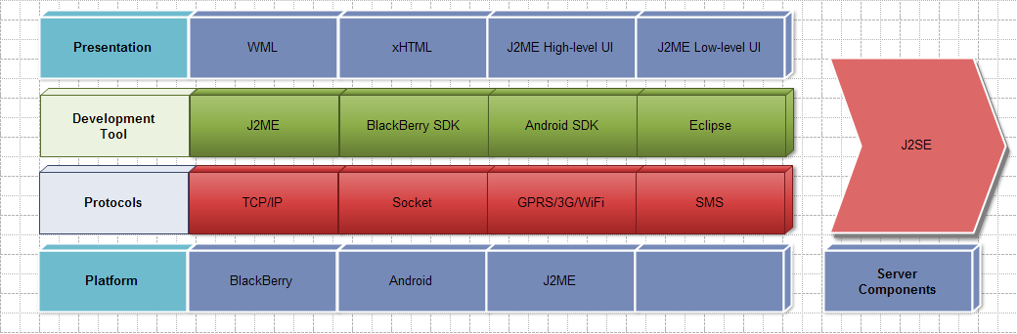

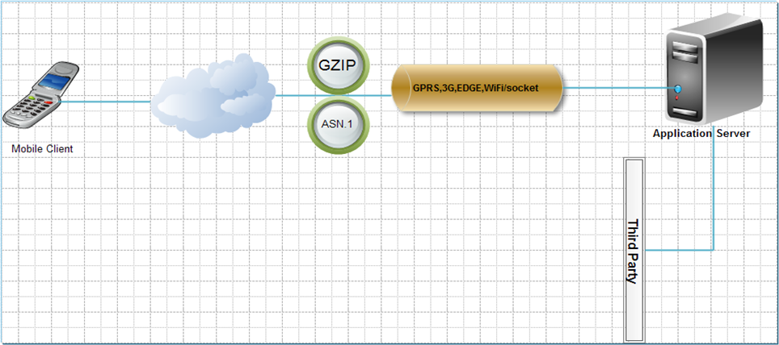

* **Application Mobile Architecture**

Point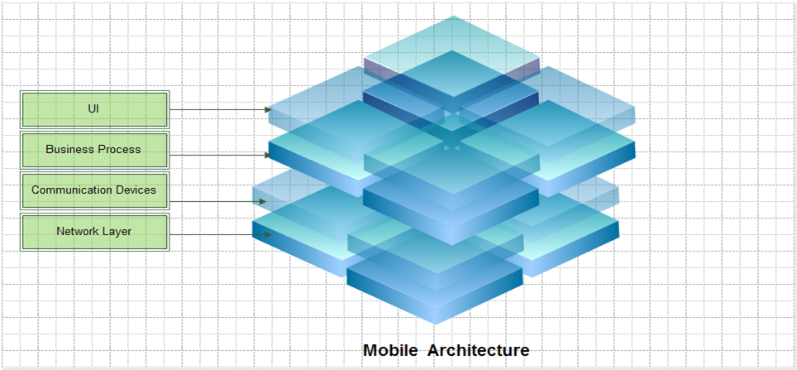

* **Messaging**

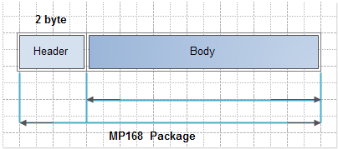

* **Application Server Architecture**

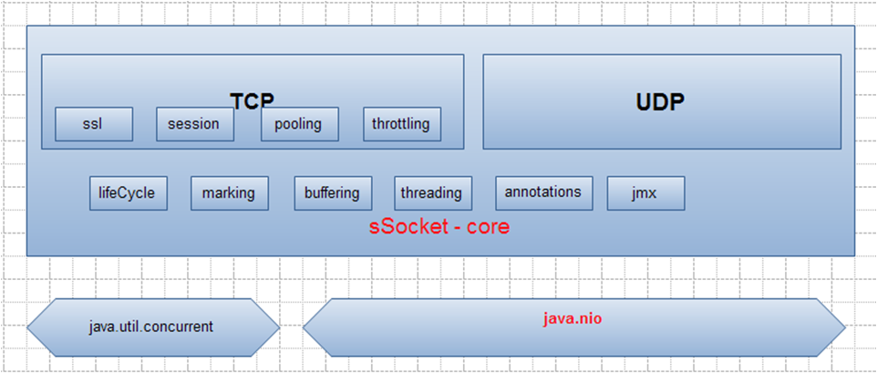

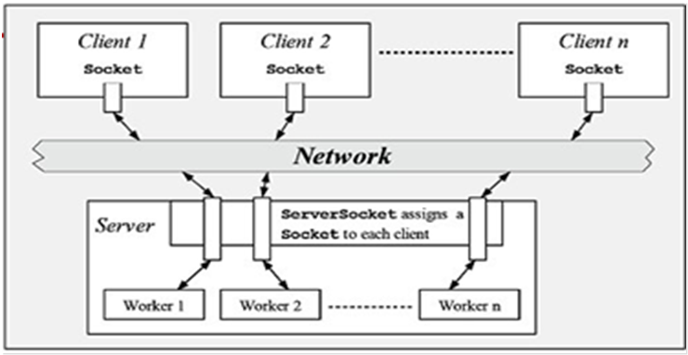

**Mobile Securities**

<http://mobitrade.vpbs.com.vn/>

<https://www.tvsi.com.vn/>

* **Technology**: oracle portal wap
* **Scope**:Development j2ee and Oracle DB
* **Features**:wap 2.0 ,html 5, *Sencha* web app frameworks, PhoneGap
* **Responsibilities**:Development all module,deployment WebSphere server

1. EDUCATION

|  |  |
| --- | --- |
| **Hanoi University of Business and Technology**   * 2008   **IBM Training Certification**   * WebSphere MQ V7.0 * WebSphere Commerce V6.0 * WebSphere Solution Sales Professional v3 * WebSphere Application Server Network Deployment V7   REFERENCES  Hung Vu  Director of SETA International Vietnam  [vu.hung@setacinq.vn](mailto:vu.hung@setacinq.vn)  Tony.Bui  CTO of SETA International Vietnam  [tony.bui@setacinq.vn](http://tony.bui@setacinq.vn) |  |
| |  | | --- | |  | |  | |  | |  | |  |

### 